**E-Healthcare Management System**

**Problem Scenario:**

In an e-healthcare management system, a patient schedules an appointment with a doctor. A patient can have multiple appointments. A patient is identified by pserial number. The system stores patient information such as their pname, age, weight, pcontact number and address. An appointment has adate, atime, status and attachment. A doctor has many appointments. Doctor stores dname, dcontact number and specialist. Also, a doctor has a specific did. To find the problem the doctor gives a test. A doctor can perform multiple tests and a specific test instance is typically performed by one doctor. Test has a unique tid, ttype, tdata and tsteps. A doctor can prescribe a prescription to a patient and a single prescription can contain one patient. Prescription can store specific presnumber, medicine name, dosage, manufacturer. A patient must pay a hospital bill. A patient can have a single hospital bill and a hospital bill is associated with only one patient. Hospital bills have a specific hbnumber, doctor charge, test fee and medicine bill. Now draw an ER diagram based on the scenario.

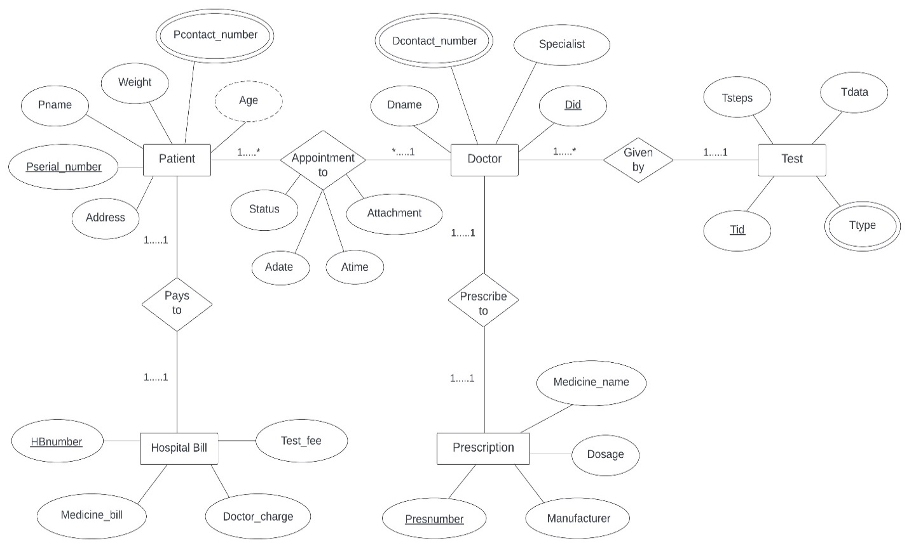**ER diagram:**

Figure : ER diagram for e-healthcare management system.

**Normalization:**

**Appointment to relation:**

UNF:

Pname, Pserial_number, Address, Weight, Age, Pcontact_number, Did, Dname, Specialist, Dcontact_number, Adate, Atime, Status, Attachment.

1NF:

Pname, Pserial_number, Address, Weight, Age, Pcontact_number, Did, Dname, Specialist, Dcontact_number, Adate, Atime, Status, Attachment.

2NF:

1. Pserial_number (PK), Pname, Address, Weight, Age, Pcontact_number, Did (FK).
2. Did (PK), Dname, Specialist, Dcontact_number.

3NF:

1. Pserial_number (PK), Pname, Address, Weight, Age, Pcontact_number, Did (FK).
2. Did (PK), Dname, Specialist, Dcontact_number.

**Pays to relation:**

UNF:

Pname, Pserial_number, Address, Weight, Age, Pcontact_number, HBserial_number, Medicine_bill, Doctor_charge, Test_fee.

1NF:

Pname, Pserial_number, Address, Weight, Age, Pcontact_number, HBserial_number, Medicine_bill, Doctor_charge, Test_fee.

2NF:

1. Pserial_number (PK), Pname, Address, Weight, Age, Pcontact_number, HBserial_number (FK).
2. HBserial_number (PK), Medicine_bill, Doctor_charge, Test_fee.

3NF:

1. Pserial_number (PK), Pname, Address, Weight, Age, Pcontact_number, HBserial_number (FK).
2. HBserial_number (PK), Medicine_bill, Doctor_charge, Test_fee.

**Given by relation:**

UNF:

Did, Dname, Specialist, Dcontact_number, Tid, Ttype, Tdata, Tsteps.

1NF:

Did, Dname, Specialist, Dcontact_number, Tid, Ttype, Tdata, Tsteps.

2NF:

1. Did (PK), Dname, Specialist, Dcontact_number, Tid (FK).
2. Tid (PK), Ttype, Tdata, Tsteps.

3NF:

1. Did (PK), Dname, Specialist, Dcontact_number, Tid (FK).
2. Tid (PK), Ttype, Tdata, Tsteps.

**Prescribe to relation:**

UNF:

Did, Dname, Specialist, Dcontact_number, Presnumber, Medicine_name, Dosage, Manufacture.

1NF:

Did, Dname, Specialist, Dcontact_number, Presnumber, Medicine_name, Dosage, Manufacture.

2NF:

1. Did (PK), Dname, Specialist, Dcontact_number, Presnumber (FK).
2. Presnumber (PK), Medicine_name, Dosage, Manufacture.

3NF:

1. Did (PK), Dname, Specialist, Dcontact_number, Presnumber (FK).
2. Presnumber (PK), Medicine_name, Dosage, Manufacture.

**Finalization:**

1. Pserial_number (PK), Pname, Address, Weight, Age, Pcontact_number, Did (FK).
2. Did (PK), Dname, Specialist, Dcontact_number.
3. Pserial_number (PK), Pname, Address, Weight, Age, Pcontact_number, HBserial_number (FK).
4. HBserial_number (PK), Medicine_bill, Doctor_charge, Test_fee.
5. Did (PK), Dname, Specialist, Dcontact_number, Tid (FK).
6. Tid (PK), Ttype, Tdata, Tsteps.
7. Did (PK), Dname, Specialist, Dcontact_number, Presnumber (FK).
8. Presnumber (PK), Medicine_name, Dosage, Manufacture.

**Create table:**

1. **Patient information:**

CREATE TABLE patient_information

(

Pserial_number NUMBER(10) NOT NULL PRIMARY KEY,

Pname VARCHAR2(225) NOT NULL,

Address VARCHAR2(255) NOT NULL,

Weight NUMBER(10) NOT NULL,

Age NUMBER(10) NOT NULL,

Pcontact_number NUMBER(11) NOT NULL,

Did NUMBER(10) NOT NULL,

CONSTRAINT patient_information_FK FOREIGN KEY (Did) REFERENCES

doctor_information(Did)

);

Desc patient_information;

1. **Doctor** **information:**

CREATE TABLE doctor_information

(

Did NUMBER(10) NOT NULL PRIMARY KEY,

Dname VARCHAR2(255) NOT NULL,

Dcontact_number NUMBER(11) NOT NULL,

Specialist VARCHAR2(255) NOT NULL

);

Desc doctor_information;

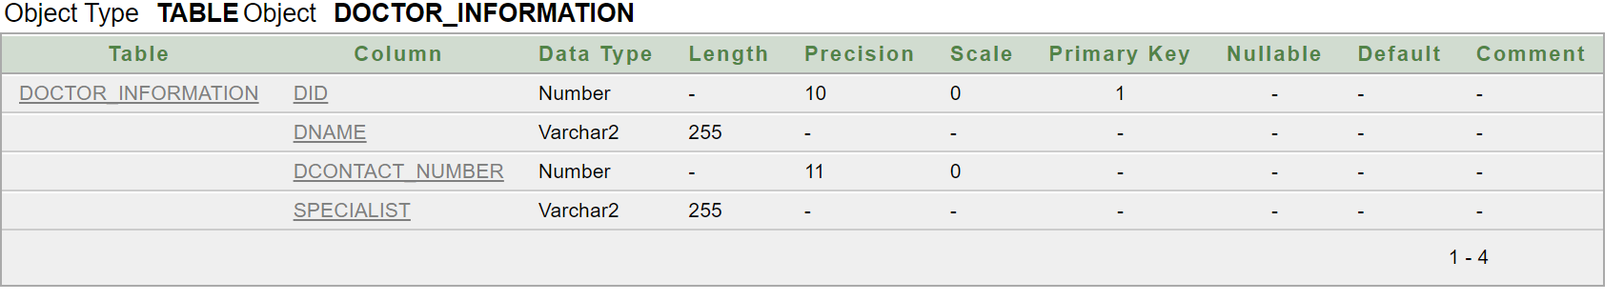

1. **Patient bill information:**

CREATE TABLE patient_bill_information

(

Pserial_number NUMBER(10) PRIMARY KEY NOT NULL,

Pname VARCHAR2(255) NOT NULL,

Address VARCHAR2(255) NOT NULL,

Pcontact_number NUMBER(11) NOT NULL,

Weight NUMBER(10) NOT NULL,

Age NUMBER(10) NOT NULL,

HBserial_number NUMBER(10) NOT NULL,

CONSTRAINT patient_bill_information_FK FOREIGN KEY (HBserial_number) REFERENCES

hospital_bill_information (HBserial_number)

);

Desc patient_bill_information;

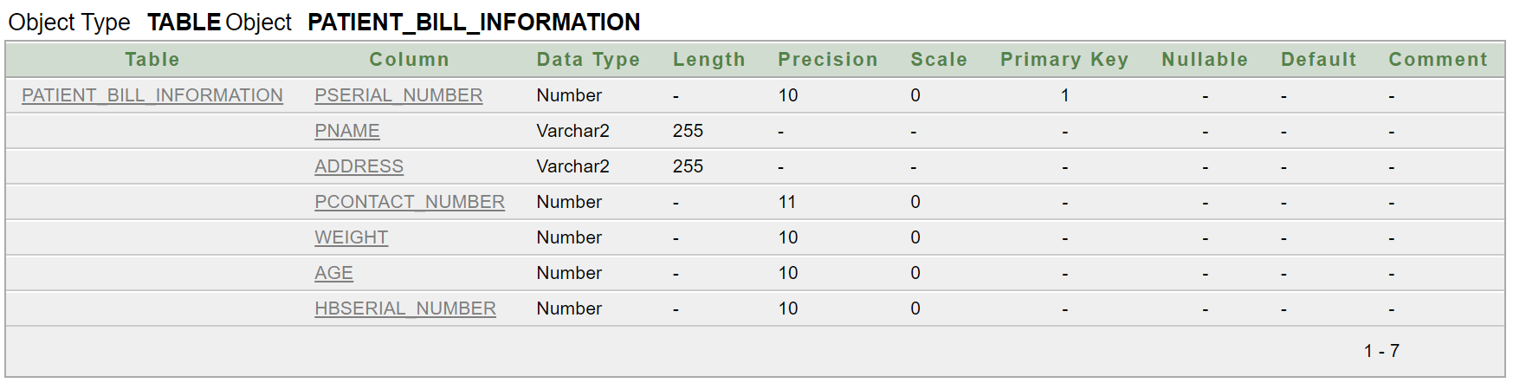

1. **Hospital bill information:**

CREATE TABLE hospital_bill_information

(

HBserial_number NUMBER(10) PRIMARY KEY NOT NULL,

Medicine_bill NUMBER(6) NOT NULL,

Doctor_charge NUMBER(7) NOT NULL,

Test_fee NUMBER(5) NOT NULL

);

Desc hospital_bill_information;

1. **Doctor test information:**

CREATE TABLE doctor_test_information

(

Did NUMBER(10) NOT NULL PRIMARY KEY,

Dname VARCHAR2(225) NOT NULL,

Specialist VARCHAR2(225) NOT NULL,

Dcontact_number NUMBER(11) NOT NULL,

Tid NUMBER(10) NOT NULL,

CONSTRAINT doctor_test_information_FK FOREIGN KEY (Tid) REFERENCES

test_information (Tid)

);

Desc doctor_test_information;

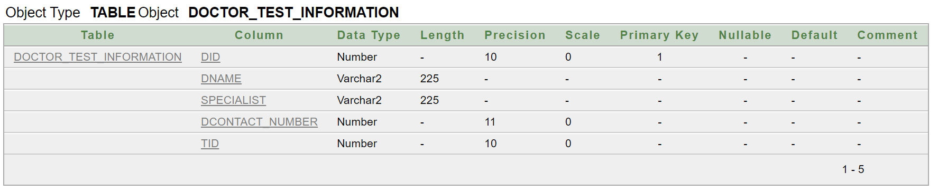

1. **Test information:**

CREATE TABLE test_information

(

Tid NUMBER(10) NOT NULL PRIMARY KEY,

Ttype VARCHAR2(255),

Tdata CHAR(100),

Tsteps NUMBER(10) NOT NULL

);

Desc test_information;

1. **Doctor Prescribed information:**

CREATE TABLE doctor_prescribed_info

(

Did NUMBER(10) NOT NULL PRIMARY KEY,

Dname VARCHAR2(225) NOT NULL,

Specialist VARCHAR2(225) NOT NULL,

Dcontact_number NUMBER(11) NOT NULL,

Presnumber NUMBER(10) NOT NULL,

CONSTRAINT doctor_prescribed_info_FK FOREIGN KEY (Presnumber) REFERENCES

prescription_information (Presnumber)

);

Desc doctor_prescribed_info;

1. **Prescription information:**

CREATE TABLE prescription_information

(

Presnumber NUMBER(10) NOT NULL PRIMARY KEY,

Medicine_name VARCHAR2(255) NOT NULL,

Dosage NUMBER(20) NOT NULL,

Manufacture DATE NOT NULL

);

**Insert value:**

1. **Patient information:**

INSERT INTO patient_information values(111,'ALEX','BRIGHTON',60,35,102382,225);

INSERT INTO patient_information values(112,'MAX','OXFORD',58,40,105473,226);

INSERT INTO patient_information values(113,'MORGAN','CAMBRIDGE',40,16,103094,238);

INSERT INTO patient_information values(114,'JOE','CAMBRIDGE',55,23,100495,240);

INSERT INTO patient_information values(115,'SMITH','MANCHESTER',58,23,101563,250);

INSERT INTO patient_information values(116,'HELLS','PRESTON',70,60,104563,290);

INSERT INTO patient_information values(117,'SCOT','PRESTON',68,40,109838,263);

INSERT INTO patient_information values(118,'ALEX','NEWCASTLE',59,38,102734,230);

INSERT INTO patient_information values(119,'PETERSON','MEDWAY TOWN',48,18,103492,234);

INSERT INTO patient_information values(120,'KANE','WATFORD',45,18,105348,224);

SELECT * FROM patient_information;

1. **Doctor information:**

INSERT INTO doctor_information VALUES(225,'Dr. Sanjay Gupta',12489356,'Neurosurgery, Medical Journalism');

INSERT INTO doctor_information VALUES(226,'Dr. Mehmet Oz',12987322,'Cardiothoracic Surgery');

INSERT INTO doctor_information VALUES(238,'Dr. Atul Gawande',12643729,'General Surgery');

INSERT INTO doctor_information VALUES(240,'Dr. Jane Goodall',12093275,'Primatology');

INSERT INTO doctor_information VALUES(250,'Dr. Ben Carson',12523284,'Neurosurgery');

INSERT INTO doctor_information VALUES(290,'Dr. Paul Farmer',12238730,'Infectious Diseases');

INSERT INTO doctor_information VALUES(263,'Dr. Michio Kaku',12098273,'Immunology');

INSERT INTO doctor_information VALUES(230,'Dr. Temple Grandin',12638295,'Eye diseases');

INSERT INTO doctor_information VALUES(234,'Dr. Ruth Westheimer',12527375,'Sex Therapy');

INSERT INTO doctor_information VALUES(224,'Dr. Anthony Fauci',12903479,'Immunology, Infectious Diseases');

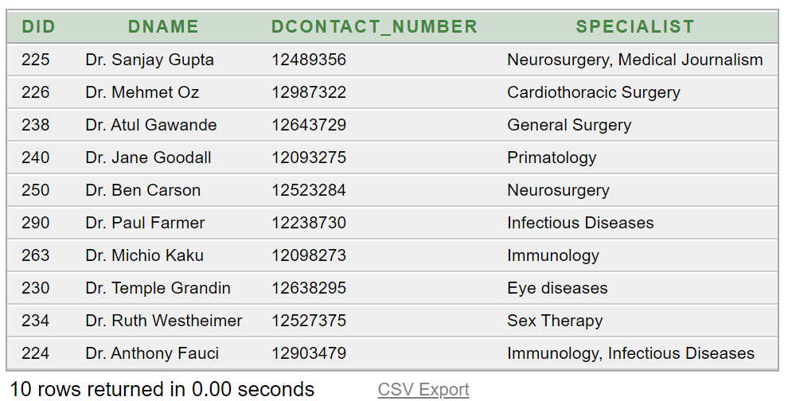SELECT * FROM doctor_information;

1. **Patient bill information:**

INSERT INTO patient_bill_information VALUES(111,'ALEX','BRIGHTON',102382,60,35,1);

INSERT INTO patient_bill_information VALUES(112,'MAX','OXFORD',105473,58,40,2);

INSERT INTO patient_bill_information VALUES(113,'MORGAN','CAMBRIDGE',103094,40,16,3);

INSERT INTO patient_bill_information VALUES(114,'JOE','CAMBRIDGE',100495,55,23,4);

INSERT INTO patient_bill_information VALUES(115,'SMITH','MANCHESTER',101563,58,23,5);

INSERT INTO patient_bill_information VALUES (116,'HELLS','PRESTON',104563,70,60,6);

INSERT INTO patient_bill_information VALUES (117,'SCOT','PRESTON',109838,68,40,7);

INSERT INTO patient_bill_information VALUES (118,'ALEX','NEWCASTLE',102734,59,38,8);

INSERT INTO patient_bill_information VALUES (119,'PETERSON','MEDWAY TOWN',103492,48,18,9);

INSERT INTO patient_bill_information VALUES (120,'KANE','WATFORD',10534845,45,18,10);

SELECT * FROM patient_bill_information;

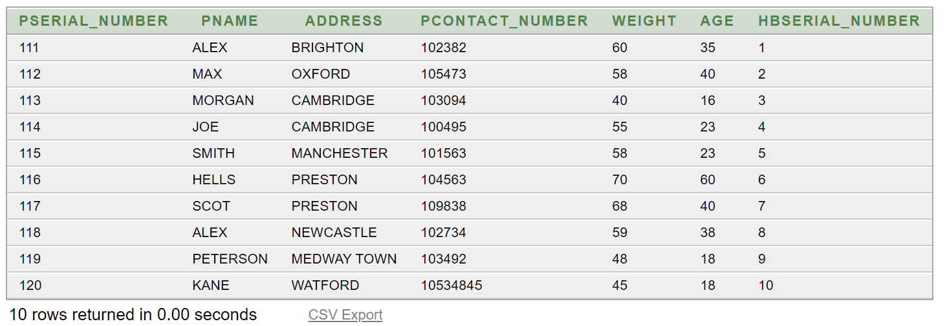

1. **Hospital bill information:**

INSERT INTO hospital_bill_information VALUES (1, 1500, 3000, 500);

INSERT INTO hospital_bill_information VALUES (2, 1020, 3001, 600);

INSERT INTO hospital_bill_information VALUES (3, 1010, 3002, 700);

INSERT INTO hospital_bill_information VALUES (4, 1900, 3004, 800);

INSERT INTO hospital_bill_information VALUES (5, 1100, 3007, 900);

INSERT INTO hospital_bill_information VALUES (6, 1200, 3010, 520);

INSERT INTO hospital_bill_information VALUES (7, 1300, 3000, 500);

INSERT INTO hospital_bill_information VALUES (8, 1400, 3100, 590);

INSERT INTO hospital_bill_information VALUES (9, 1700, 3900, 100);

INSERT INTO hospital_bill_information VALUES (10, 1600, 3600, 590);

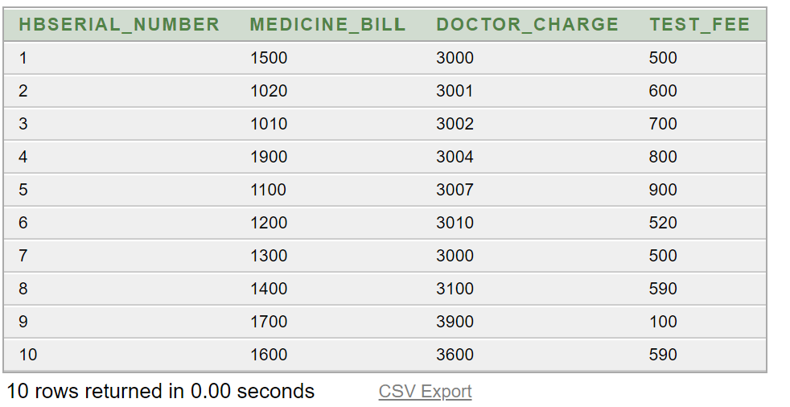SELECT * FROM hospital_bill_information;

1. **Doctor test information:**

INSERT INTO doctor_test_information VALUES(225,'Dr. Sanjay Gupta',' Neurosurgery, Medical Journalism',12489356,65);

INSERT INTO doctor_test_information VALUES(226,'Dr. Mehmet Oz','Cardiothoracic Surgery',12987322,45);

INSERT INTO doctor_test_information VALUES(238,'Dr. Atul Gawande','General Surgery',12643729,55);

INSERT INTO doctor_test_information VALUES(240,'Dr. Jane Goodall','Primatology',12093275,89);

INSERT INTO doctor_test_information VALUES(250,'Dr. Ben Carson','Neurosurgery',12523284,11);

INSERT INTO doctor_test_information VALUES(290,'Dr. Paul Farmer','Infectious Diseases',12238730,18);

INSERT INTO doctor_test_information VALUES(263,'Dr. Michio Kaku','Immunology',12098273,23);

INSERT INTO doctor_test_information VALUES(230,'Dr. Temple Grandin','Eye diseases',12638295,26);

INSERT INTO doctor_test_information VALUES(234,'Dr. Ruth Westheimer','Sex Therapy',12527375,29);

INSERT INTO doctor_test_information VALUES(224,'Dr. Anthony Fauci','Immunology,Infectious Diseases',12903479,64);

SELECT * FROM doctor_test_information;

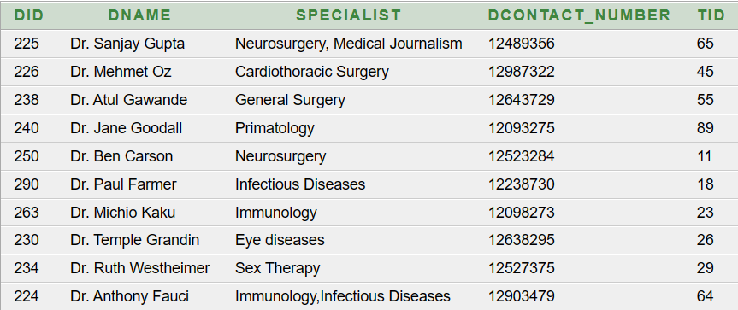

1. **Test information:**

INSERT INTO test_information VALUES(65,'P','Data 1',1);

INSERT INTO test_information VALUES(45,'P','Data 2',2);

INSERT INTO test_information VALUES(55,'N','Data 3',3);

INSERT INTO test_information VALUES(89,'N','Data 4',4);

INSERT INTO test_information VALUES(11,'N','Data 5',5);

INSERT INTO test_information VALUES(18,'P','Data 6',6);

INSERT INTO test_information VALUES(23,'P','Data 7',7);

INSERT INTO test_information VALUES(26,'N','Data 8',8);

INSERT INTO test_information VALUES(29,'P','Data 9',9);

INSERT INTO test_information VALUES(64,'N','Data 10',10);

SELECT * FROM test_information;

1. **Doctor prescribed information:**

INSERT INTO doctor_prescribed_info VALUES (225, 'Dr. Sanjay Gupta', 'Neurosurgery, Medical Journalism', 12489356, 1);

INSERT INTO doctor_prescribed_info VALUES (226, 'Dr. Mehmet Oz', 'Cardiothoracic Surgery', 12987322, 2);

INSERT INTO doctor_prescribed_info VALUES (238, 'Dr. Atul Gawande', 'General Surgery', 12643729, 3);

INSERT INTO doctor_prescribed_info VALUES (240, 'Dr. Jane Goodall', 'Primatology', 12093275, 4);

INSERT INTO doctor_prescribed_info VALUES (250, 'Dr. Ben Carson', 'Neurosurgery', 12523284, 5);

INSERT INTO doctor_prescribed_info VALUES (290, 'Dr. Paul Farmer', 'Infectious Diseases', 12238730, 6);

INSERT INTO doctor_prescribed_info VALUES (263, 'Dr. Michio Kaku', 'Immunology', 12098273, 7);

INSERT INTO doctor_prescribed_info VALUES (230, 'Dr. Temple Grandin', 'Eye diseases', 12638295, 8);

INSERT INTO doctor_prescribed_info VALUES (234, 'Dr. Ruth Westheimer', 'Sex Therapy', 12527375, 9);

INSERT INTO doctor_prescribed_info VALUES (224, 'Dr. Anthony Fauci', 'Immunology, Infectious Diseases', 12903479, 10);

SELECT * FROM doctor_prescribed_info;

1. **Prescription information:**

INSERT INTO prescription_information VALUES(01, 'napa', 3, '02-feb-2022');

INSERT INTO prescription_information VALUES(02, 'amodis', 3, '03-feb-2022');

INSERT INTO prescription_information VALUES(03, 'tofen', 250, '02-jan-2022');

INSERT INTO prescription_information VALUES(04, 'maxpro', 500, '12-mar-2022');

INSERT INTO prescription_information VALUES(05, 'fexo', 120, '02-may-2023');

INSERT INTO prescription_information VALUES(06, 'monas', 10, '02-sep-2022');

INSERT INTO prescription_information VALUES(07, 'adecard', 6, '28-feb-2022');

INSERT INTO prescription_information VALUES(08, 'alactrol', 50, '02-dec-2022');

INSERT INTO prescription_information VALUES(09, 'ambrox', 75, '02-nov-2022');

INSERT INTO prescription_information VALUES(10, 'tylenol', 120, '02-mar-2022');

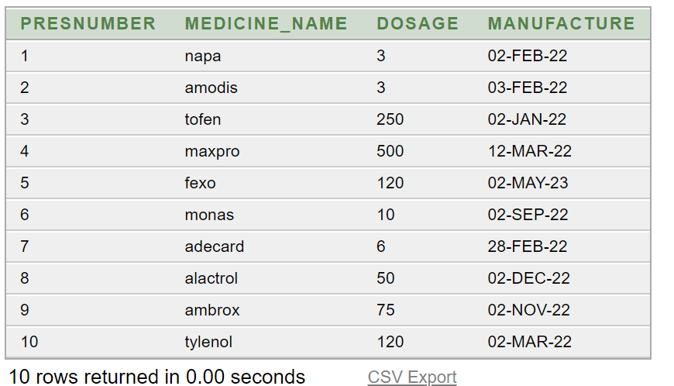SELECT * FROM prescription_information;

**Query:**

1. 1)SELECT pname,pserial_number from patient_information;

2)SELECT pname,pserial_number,weight, weight*1000 AS weight_GM from patient_information;

3)SELECT pname, weight, 10+(weight*1000) AS weight_GM from patient_information;

4)SELECT pname||' '||'lives in'||' '||address from patient_information;

1. 1)select pname from PITI_bill_information where pname like'%A%';

2)select dname from doctor_test_information where dname like'%Gawande%';

1. 1)select Medicine_bill from hospital_bill_information where Medicine_bill>1100 and Doctor_charge<5000;

2)SELECT * FROM hospital_bill_information WHERE Medicine_bill > 1100 OR Test_fee > 600;

3)SELECT * FROM prescription_information WHERE dosage <> 500;

1. 1)SELECT pname, weight,age from patient_information ORDER BY weight, age DESC;

2)SELECT Presnumber, dosage,Manufacture FROM prescription_information ORDER BY dosage, Manufacture DESC;

1. 1)SELECT * FROM Doctor_information WHERE UPPER(Dname) LIKE '%Ben%';

2)SELECT * FROM PITI_bill_information WHERE UPPER(Pname) LIKE 'ALEX';

1. 1)SELECT Dname, CONCAT (Dname, Dcontact_number), LENGTH(Specialist) from Doctor_information;

2)SELECT Pname,Address,LENGTH(Address),INSTR(Pname,'A') from PITI_bill_information ;

1. 1)SELECT * FROM prescription_information WHERE Manufacture > TO_DATE('2023-01-01', 'YYYY-MM-DD');

2)SELECT TO_CHAR(MANUFACTURE, 'YYYY') AS spelled_year, TO_CHAR(MANUFACTURE, 'MONTH') AS spelled_month FROM prescription_information;

1. SELECT Specialist, DECODE(Specialist, 'Cardiology', 'Revised Cardiology', Specialist) AS REVISED_SPECIALIZATION FROM doctor_information;
2. 1) SELECT MAX(Medicine_bill) AS Max_Medicine_Bill, MAX(Doctor_charge) AS Max_Doctor_Charge, MAX(Test_fee) AS Max_Test_Fee FROM hospital_bill_information;

2) SELECT MIN(Medicine_bill) AS Min_Medicine_Bill, MIN(Doctor_charge) AS Min_Doctor_Charge, MIN(Test_fee) AS Min_Test_Fee FROM hospital_bill_information;

3) SELECT AVG(Medicine_bill) AS Avg_Medicine_Bill, AVG(Doctor_charge) AS Avg_Doctor_Charge, AVG(Test_fee) AS Avg_Test_Fee FROM hospital_bill_information;